Free Comic Strip Creator Sites

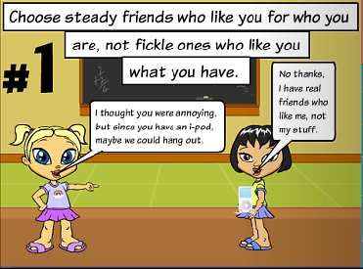

<http://www.toondoo.com/>

(create free account)

<http://www.makebeliefscomix.com/>

(no account needed)

<http://writecomics.com/>

(no account needed)

<http://marvelkids.marvel.com/games/play/75/create_your_own_comic>

(no account needed)

<http://professorgarfield.org/pgf_comics_lab.html>

(create name but no password or sign up)

